|  |  |  |  |
| --- | --- | --- | --- |
| Vishwakarma Institute of Technology - Wikipedia | Bansilal Ramnath Agarwal Charitable Trust’s  Vishwakarma Institute of Information Technology  Department of  Artificial Intelligence and Data Science | | |
| Student Name: Siddhesh Dilip Khairnar | | | |
| Class: TY | Division: B | | Roll No.: 372028 |
| Semester: 5 | | Academic Year: 2023-24 | |
| Subject Name & Code: Cloud Computing and Analytics, ADUA31203 | | | |
| Title of Assignment: Deploy static website on cloud using S3 bucket. | | | |

Assignment No.- 04

**What is AWS S3 bucket:**

Amazon S3 (Simple Storage Service) is a scalable, secure, and highly available object storage service offered by Amazon Web Services (AWS). An S3 bucket is the fundamental container within Amazon S3 used to store and organize data. Here are some key characteristics and features of S3 buckets:

* **Data Storage**: S3 buckets are used to store a wide variety of data, including text and binary data, images, videos, documents, backups, and more. It is not limited to specific types of files.
* **Scalability**: S3 is designed to be highly scalable. You can store virtually unlimited amounts of data in an S3 bucket, and AWS automatically scales the infrastructure to accommodate your storage needs.
* **Durability**: S3 provides high durability for your data. It replicates data across multiple Availability Zones within a region to ensure data redundancy and protection against hardware failures.
* **Availability**: S3 offers high availability, meaning your data is accessible and reliable. It provides a service-level agreement (SLA) guaranteeing 99.99% availability.
* **Security**: S3 allows you to control access to your data using bucket policies, Access Control Lists (ACLs), and Identity and Access Management (IAM) policies. You can define who can read, write, and delete objects in a bucket.

**Difference between block storage and object storage:**

|  |  |  |
| --- | --- | --- |
| **Capability** | **Block storage** | **Object storage** |
| **Storage capacity** | Limited | Nearly unlimited |
| **Storage method** | Data stored in blocks of fixed size, reassembled on demand | Unstructured data in non-hierarchical data lake |
| **Metadata** | Limited | Unlimited and customizable |
| **Data retrieval method** | Data lookup table | Customizable |
| **Performance** | Fast, especially for small files | Depends, but works well with large files |
| **Cost** | Depends on vendor, usually more expensive | Depends on vendor, usually less expensive (aside from [egress fees](https://www.cloudflare.com/learning/cloud/what-are-data-egress-fees/)) |

**S3 Storage classes in AWS:**

Amazon S3 (Simple Storage Service) offers a variety of storage classes to meet different data storage and access requirements. Each storage class is designed to optimize cost, durability, and performance based on specific use cases. Here's an overview of the key S3 storage classes in AWS:

**S3 Standard:** For frequently accessed data.

**S3 Intelligent-Tiering**: Automatically adjusts between frequent and infrequent access.

**S3 Standard-IA**: For infrequent access with quick retrieval.

**S3 One Zone-IA:** For infrequent access with lower durability.

**S3 Glacier**: For archival with retrieval in minutes to hours.

**S3 Glacier Deep Archive**: For long-term archival with slower retrieval.

**S3 Outposts:** Extends S3 to on-premises AWS Outposts.

**S3 Replication Options:** For data redundancy and disaster recovery.

Choose the one that matches your data access, durability, and cost requirements. Use S3 lifecycle policies and cost optimization tools to manage costs effectively.

**Steps to deploy static website on cloud using s3 bucket :**

1. **Create an S3 Bucket:**

* Navigate to the Amazon S3 service.
* Click the "Create bucket" button.
* Choose a unique and meaningful name for your bucket (e.g., "my-static-website").
* Select the AWS region where you want to create the bucket and click "Next."

1. **Enable Static Website Hosting:**

After creating your S3 bucket and navigating to the bucket's overview page:

* Click on the bucket name to open the bucket's settings.
* In the top navigation tabs, locate and click on the "Properties" tab.
* Scroll down to find the "Static website hosting" card.
* Click on it, and in the "Static website hosting" section, select the "Enabled" option.
* Specify the "Index document" (usually "index.html") as the default page for your website.
* Optionally, specify an "Error document" if you have a custom error page (e.g., "error.html").
* Click the "Save changes" button to save your settings.

1. **Upload Files in S3 Bucket:**

* Click on the S3 bucket where you want to upload files. This will open the bucket's overview page
* On the bucket's overview page, click the "Upload" button.
* Click the "Add files" button to select the files you want to upload from your local file system.

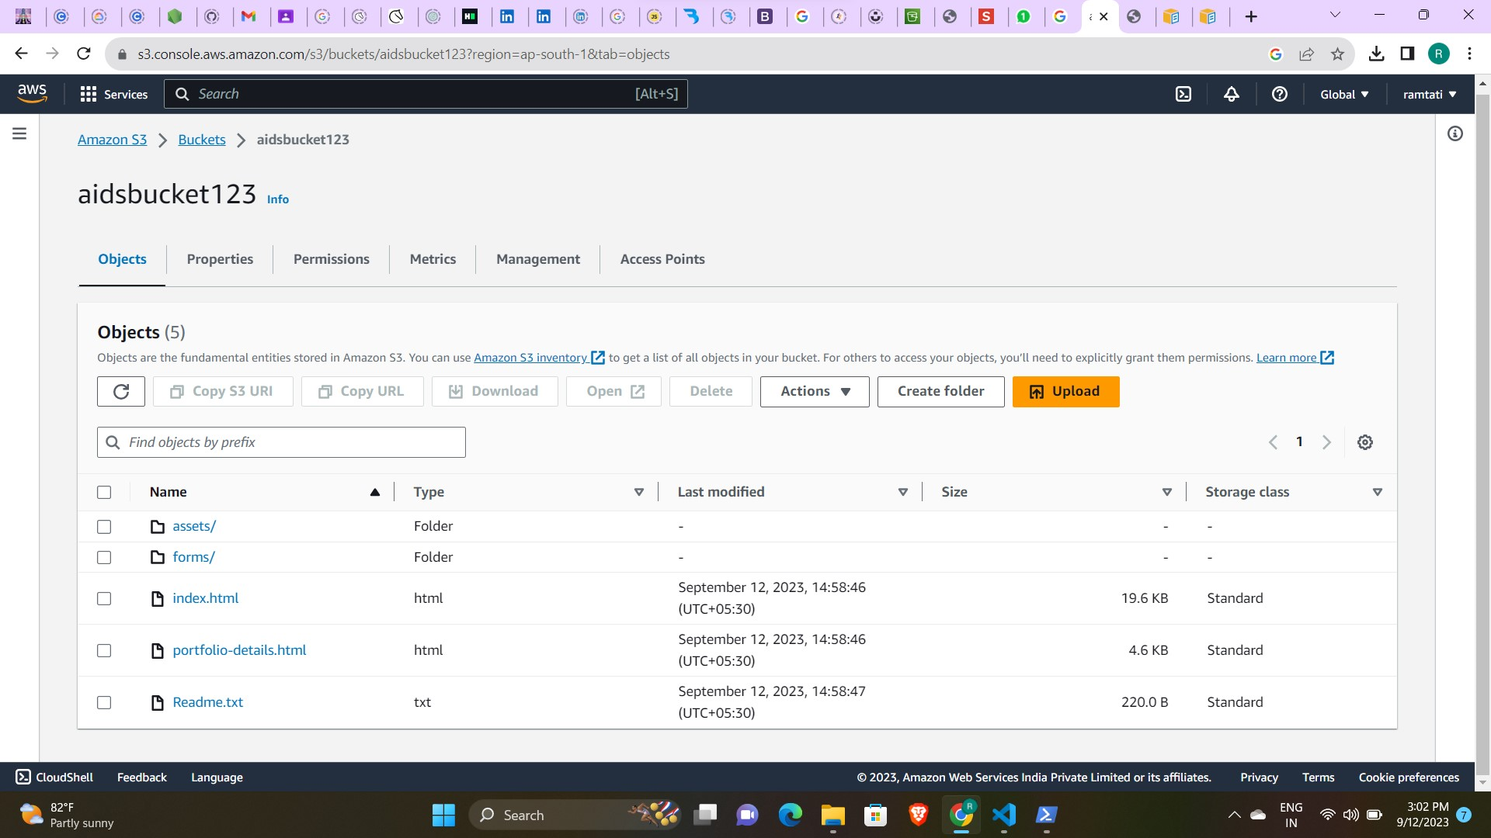

1. **Add a bucket policy:**

* Under Buckets, choose the name of your bucket.
* Choose Permissions.
* Under Bucket Policy, choose Edit.
* To grant public read access for your website, copy the following bucket policy, and paste it in the Bucket policy editor. Change bucket

{

"Version": "2012-10-17",

"Statement": [

{

"Sid": "PublicReadGetObject",

"Effect": "Allow",

"Principal": "*",

"Action": [

"s3:GetObject"

],

"Resource": [

"arn:aws:s3:::Bucket-Name/*"

]

}

]

}

1. **Access Your S3 Bucket Website:**

* In the S3 bucket's overview page, scroll down to the "Permissions" tab.
* Under the "Static Website Hosting" card, Copy ARN
* bucket's ARN (Amazon Resource Name). This ARN is your static website's URL.
* In the address bar of your web browser, paste the ARN or URL you copied.
* Press "Enter" or click "Go."

**Conclusion:**

**Thus, we have deployed static website on cloud using AWS S3 bucket service.**